**Q1:**

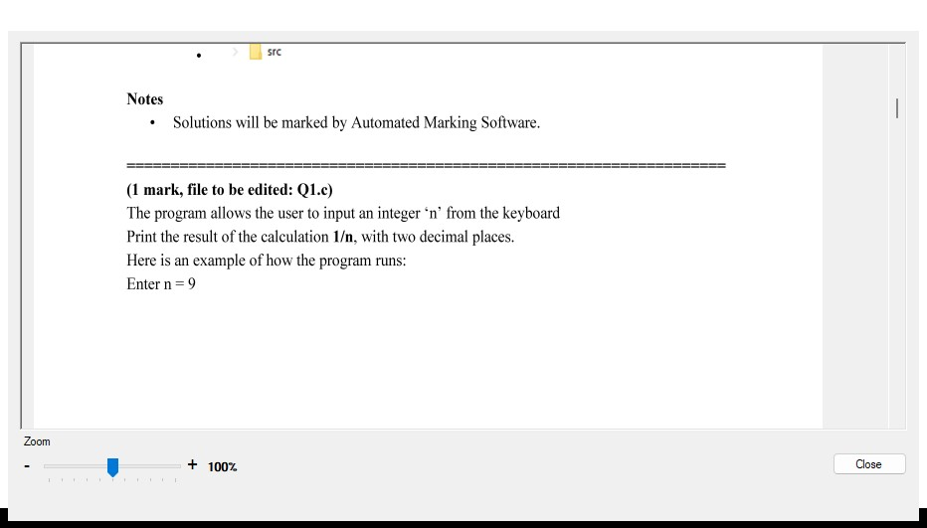

[**#include**](https://www.facebook.com/hashtag/include?__eep__=6&__tn__=R*F) <stdio.h>

int main() {

int n;

printf("Enter an integer n: ");

scanf("%d", &n);

float result = 1.0 / n;

printf("Result: %.2f\n", result);

return 0;

}

**Q3:**

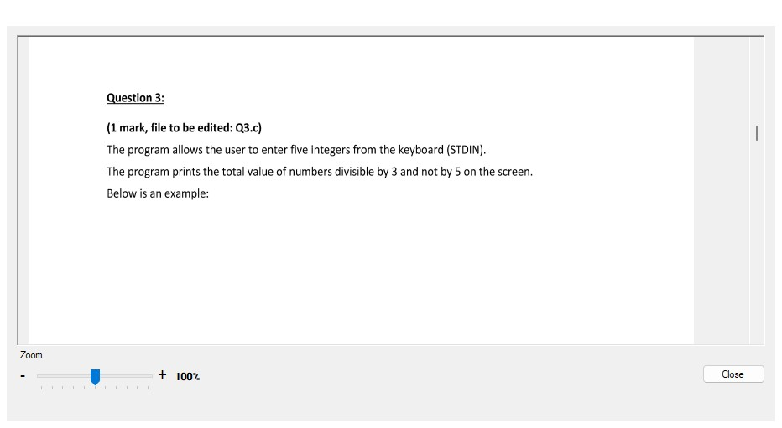

#include <stdio.h>

#include <stdlib.h>

#include <string.h>

#include <math.h>

[**#include**](https://www.facebook.com/hashtag/include?__eep__=6&__tn__=R*F) <ctype.h>

int main() {

system("cls");

//INPUT - @STUDENT:ADD YOUR CODE FOR INPUT HERE:

int numbers[5];

int i, sum = 0;

// Read in numbers

for (i = 0; i < 5; i++) {

scanf("%d", &numbers[i]);

}

// Compute sum of numbers divisible by 3 and not by 5

for (i = 0; i < 5; i++) {

if (numbers[i] % 3 == 0 && numbers[i] % 5 != 0) {

sum += numbers[i];

}

}

// Fixed Do not edit anything here.

printf("\nOUTPUT:\n");

//@STUDENT: WRITE YOUR OUTPUT HERE:

printf("%d", sum);

//--FIXED PART - DO NOT EDIT ANY THINGS HERE

printf("\n");

system ("pause");

return(0);}

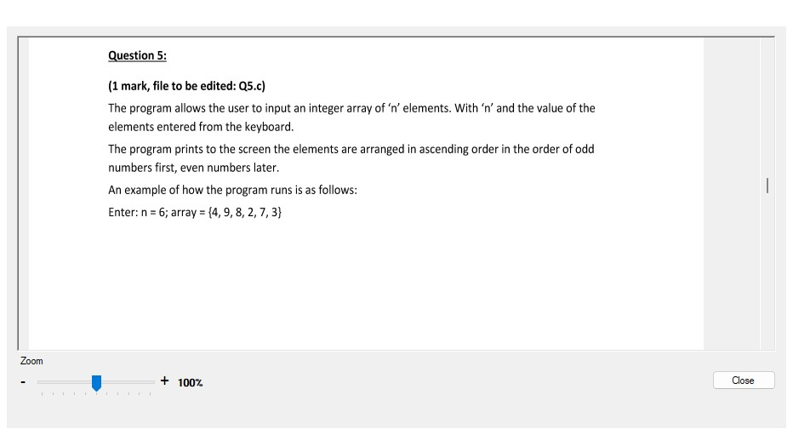

[**#include**](https://www.facebook.com/hashtag/include?__eep__=6&__tn__=R*F) <stdio.h>

int main() {

int n;

printf("Enter the size of the array: ");

scanf("%d", &n);

int arr[n];

printf("Enter %d elements of the array:\n", n);

for (int i = 0; i < n; i++) {

scanf("%d", &arr[i]);

}

// Sort the odd and even numbers separately using bubble sort

for (int i = 0; i < n-1; i++) {

for (int j = 0; j < n-i-1; j++) {

if (arr[j] % 2 == 0 && arr[j+1] % 2 != 0) {

// Swap adjacent even and odd numbers

int temp = arr[j];

arr[j] = arr[j+1];

arr[j+1] = temp;

}

else if (arr[j] % 2 == arr[j+1] % 2 && arr[j] > arr[j+1]) {

// Swap adjacent numbers if they're of the same parity

int temp = arr[j];

arr[j] = arr[j+1];

arr[j+1] = temp;

}

}

}

// Print the sorted array

printf("Array in ascending order with odd numbers first and even numbers later:\n");

for (int i = 0; i < n; i++) {

printf("%d ", arr[i]);

}

printf("\n");

return 0;

}

**Q6:**

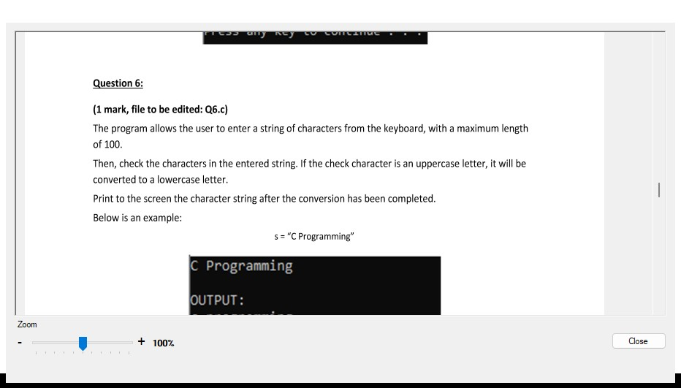

#include <stdio.h>

[**#include**](https://www.facebook.com/hashtag/include?__eep__=6&__tn__=R*F) <ctype.h>

int main() {

char s[100];

printf("Enter a string: ");

fgets(s, sizeof(s), stdin);

for (int i = 0; s[i] != '\0'; i++) {

// Convert uppercase letters to lowercase

if (isupper(s[i])) {

s[i] = tolower(s[i]);

}

}

printf("String after conversion: %s\n", s);

return 0;

}

**-----------------------------------**

**C2:** **#include <stdio.h>**

**#include <math.h>**

**#include <ctype.h>**

**int main(){**

**char s[100]= "";**

**fgets(s,sizeof(s),stdin);**

**strlwr(s);**

**puts(s);**

**}**

**Q7:**

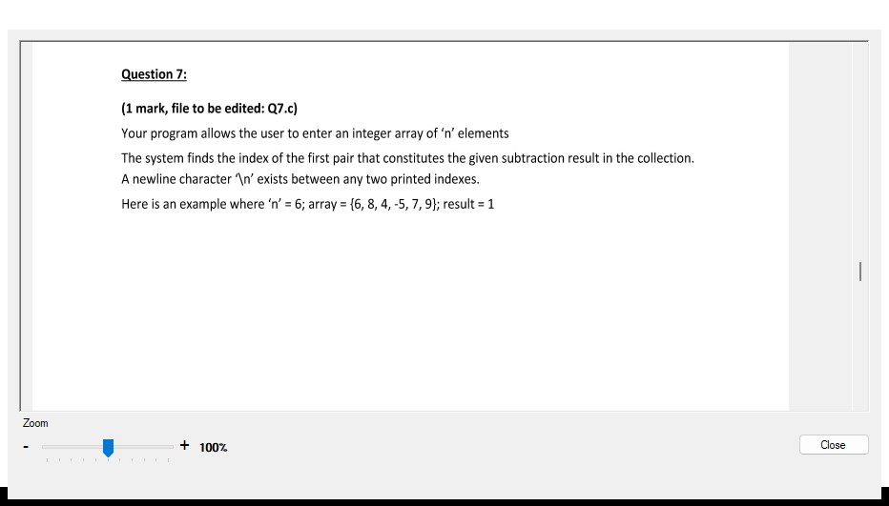

[**#include**](https://www.facebook.com/hashtag/include?__eep__=6&__tn__=R*F) <stdio.h>

int main() {

int n;

printf("Enter the size of the array: ");

scanf("%d", &n);

int arr[n];

printf("Enter %d elements of the array:\n", n);

for (int i = 0; i < n; i++) {

scanf("%d", &arr[i]);

}

int result;

printf("Enter the subtraction result: ");

scanf("%d", &result);

for (int i = 0; i < n; i++) {

for (int j = i+1; j < n; j++) {

if (arr[i] - arr[j] == result || arr[j] - arr[i] == result) {

printf("Indices: %d\n%d\n", i, j);

return 0;

}

}

}

printf("No such pair exists.\n");

return 0;

}

**Q8:**

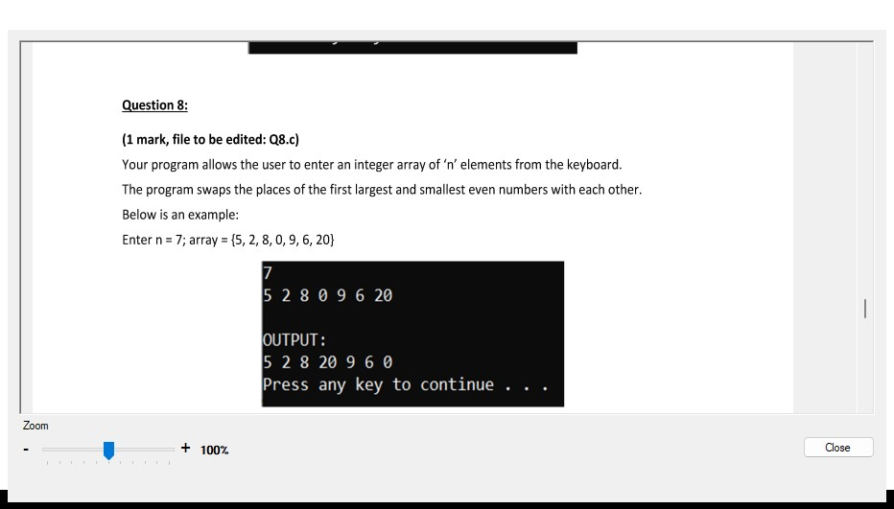

[**#include**](https://www.facebook.com/hashtag/include?__eep__=6&__tn__=R*F) <stdio.h>

int main() {

int n;

printf("Enter the size of the array: ");

scanf("%d", &n);

int arr[n];

printf("Enter %d elements of the array:\n", n);

for (int i = 0; i < n; i++) {

scanf("%d", &arr[i]);

}

int smallest_even_index = -1, largest_even_index = -1;

int smallest_even = 99999999, largest_even = -99999999;

// Find the index of the first smallest and largest even numbers

for (int i = 0; i < n; i++) {

if (arr[i] % 2 == 0) {

if (arr[i] < smallest_even) {

smallest_even = arr[i];

smallest_even_index = i;

}

if (arr[i] > largest_even) {

largest_even = arr[i];

largest_even_index = i;

}

}

}

// Swap the positions of the smallest and largest even numbers

if (smallest_even_index != -1 && largest_even_index != -1) {

int temp = arr[smallest_even_index];

arr[smallest_even_index] = arr[largest_even_index];

arr[largest_even_index] = temp;

}

// Print the updated array

printf("Updated array: ");

for (int i = 0; i < n; i++) {

printf("%d ", arr[i]);

}

printf("\n");

return 0;

}

**Q9:**

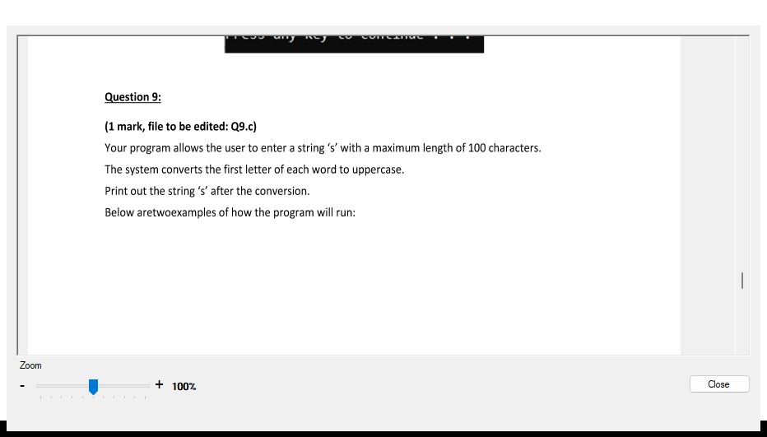

#include <stdio.h>

[**#include**](https://www.facebook.com/hashtag/include?__eep__=6&__tn__=R*F) <ctype.h>

int main() {

char s[100];

printf("Enter a string: ");

fgets(s, sizeof(s), stdin);

for (int i = 0; s[i] != '\0'; i++) {

// Capitalize the first letter of each word

if (i == 0 || s[i-1] == ' ') {

s[i] = toupper(s[i]);

}

}

printf("String after conversion: %s\n", s);

return 0;

}

**Q10:**

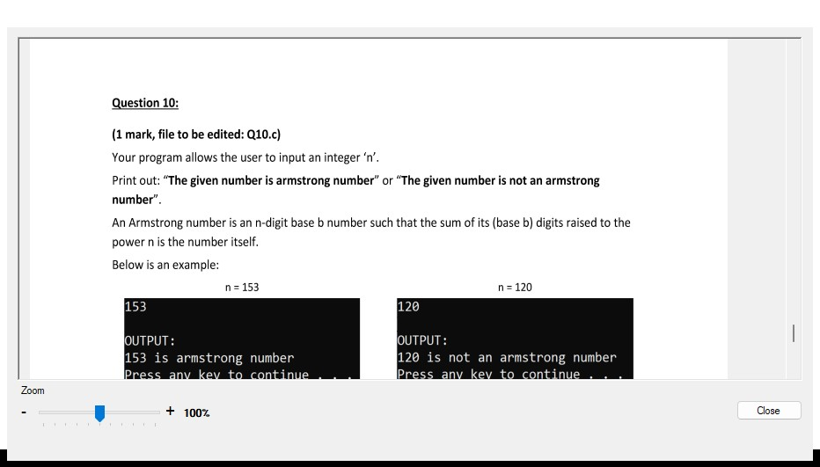

#include <stdio.h>

[**#include**](https://www.facebook.com/hashtag/include?__eep__=6&__tn__=R*F) <math.h>

int main() {

int num, originalNum, remainder, n = 0;

float result = 0.0;

printf("Enter an integer: ");

scanf("%d", &num);

originalNum = num;

// Count the number of digits in the given number

while (originalNum != 0) {

originalNum /= 10;

++n;

}

originalNum = num;

// Calculate the sum of each digit raised to the power n

while (originalNum != 0) {

remainder = originalNum % 10;

result += pow(remainder, n);

originalNum /= 10;

}

// Check if the calculated sum is equal to the original number

if ((int)result == num) {

printf("The given number is an Armstrong number.\n");

}

else {

printf("The given number is not an Armstrong number.\n");

}

return 0;

}